We Remember...
We Acknowledge...
We Hope...

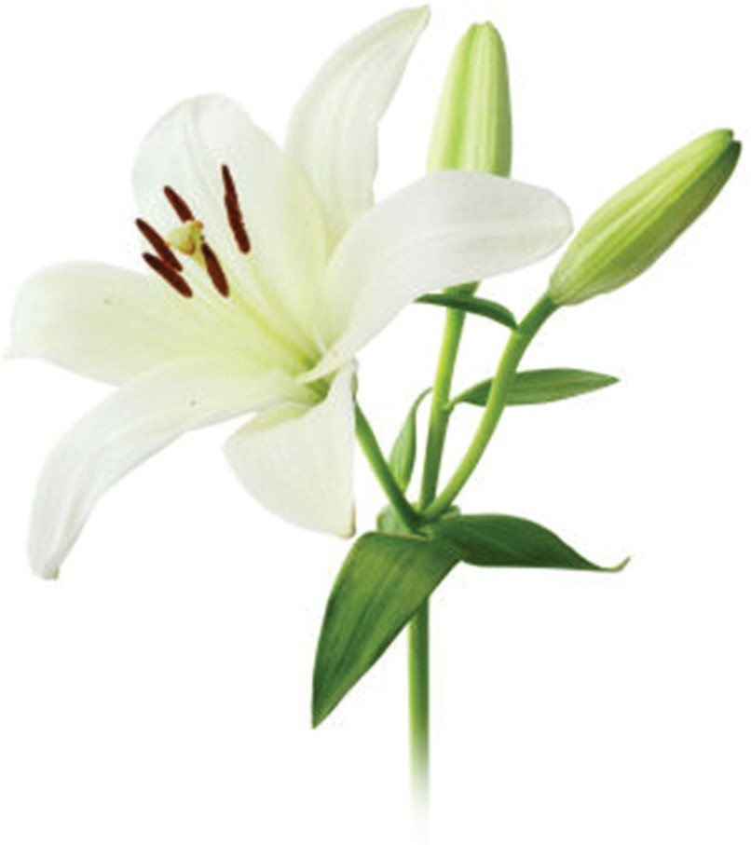

Guidelines for Families Planning Catholic Funerals in the Diocese of Paisley

Beloved Child of God, we entrust you to Him Who created you.
May you return to the One Who formed you from the dust of this earth.
May Mary, the angels, and all the saints come to meet you as you go forth from this life.
May Christ, Who was crucified for you bring you freedom and peace.
May Christ, the Son of God, Who died for you take you into His kingdom.
May Christ, the Good Shepherd, give you a place within His flock.
May He forgive your sins and keep you among His people.
May you see your Redeemer face to face and enjoy the sight of God forever.
Amen

Introduction
THE CHURCH offers you its most sincere condolences as you suffer the loss of someone you loved. Having suffered this loss, the Church would now like to help you to honour their memory, to listen with you to words of comfort and consolation and to pray for the repose of your loved one’s soul. Having remembered, having acknowledged the pain of grief and loss and having prayed together, our hope is that you might begin to feel more at peace in our faith that the person whom you loved is at rest in God.

What to Expect
THE PARISH PRIEST will meet with you and your family to help plan a funeral which reflects the Catholic understanding of our relationship with God and how best to respond to the death of a loved one.

Your Parish Priest is, of course, bound to follow Catholic traditions as well as Church and local civil law. He will meet with you and your family, to help you select appropriate hymns and prayers to be used during the various services, to plan your own participation in those services, if you wish, and to learn more about the life of the person who has passed away so that these ideas may be incorporated into the homily he will give during the Funeral, or Requiem, Mass itself. The Funeral Director with whom you are working will take care of many of the practical details. However, the Parish Priest will arrange details at the church itself.

The Various Stages of a Catholic Funeral
THE FUNERAL MASS is normally the heart of a Catholic funeral but the rites can unfold in stages, as you wish.

In the Days Preceding
It is now much less often the case, but some families desire to bring the body of the deceased to the family home for some time before the funeral. If you do, please contact the Parish Priest, or ask the Funeral Director do so on your behalf, if you wish him to come to your home to recite the rosary or otherwise pray with you and to see if he is free to do so. As you will know, he has many demands on his time, so in some places it is the custom for the parish deacon, parish sister, or a member of a parish organisation to attend rather than the Parish Priest.

The Evening Before and on the Day
Ordinarily, the funeral rites begin with a Vigil the night before the Requiem Mass. During this brief service, the remains of the deceased are welcomed into the church. This service might be led by the Parish Priest or, in his absence, by the parish deacon or sister. At its conclusion, and if the priest is present, there might be the opportunity for those present to go to confession in preparation for the next day’s Eucharist.

Not all families desire to bring the body of their loved one to the church the evening before the funeral but prefer to have the reception of the body just before the Funeral Mass itself. This is perfectly acceptable. Similarly, the Parish Priest may not be available the evening before. In some very busy parishes, where there are numerous funerals, it may not always be possible to arrange the Vigil the evening before the Mass. Please check with the Parish Priest before arranging this part of the funeral rites.

The next day, the funeral rites continue with the Mass itself and then conclude either with a brief service at the graveside or at a crematorium.

Should the family opt for cremation rather than burial, it is nonetheless Catholic custom that the remains be buried or otherwise entombed. The presence of our loved one’s remains in a cemetery keeps them more firmly in our minds and the burial of remains, rather than their division and scattering, is a more powerful reminder of the resurrection of our bodies in which we hope.

How We Understand Death and Our Funeral Rites
PRAYER FOR THE DEAD plays a central

role in our funeral rites. In this, our Catholic tradition differs from other Christian bodies in Scotland.

Blessed Happy are those who mourn for they shall be comforted.
Matthew 5:4

Hopeful Prayer for Consolation and Resurrection
As Catholics we have the Risen Lord as the centre of our funeral liturgy. Jesus—and your loved one’s sharing in His resurrection—is the principle focus of what is to take place. In the Christian traditions of other Churches, and in other traditions, such as Humanism, much time is spent remembering the person who has passed away. We remember as well, but we also acknowledge grief and loss in our prayers and hope for resurrection. This difference is sometimes very obvious to people who expect one thing and experience another.

Baptism and Its Symbols Baptism, our original sharing in the death and

resurrection of the Lord Jesus, figures prominently in our funeral rites. Holy water and the other symbols of baptism play a prominent part in a funeral. The liturgy revolves around the Risen Lord, present among us, who reminds us that through death we share resurrection, that in the midst of pain we have consolation and, in mourning, joy is possible for through our memories, our faith, our hope and our charity, good may come of events that we find so painful now.

Do you not know that all of us
who have been baptised into Christ Jesus were baptised into his death? Therefore we have been buried with him by baptism into death, so that, just as Christ was raised from the dead by the glory of the Father, so we too might walk in newness of life. Romans 6:3-5

Your Participation is Warmly Sought
THE FAMILY are encouraged to take a full part in the Funeral Mass in the way that they would normally in any ordinary celebration of Mass, by listening and responding to the prayers, the scriptures and words of encouragement by the priest, and to sing and pray at the appropriate times. There are many other ways in which you and your family may participate in all of the rites if you wish. Your Parish Priest will lead you through them.
Speaking During the Funeral Rites
YOU ARE INVITED to share some words of welcome, or in appreciation of the support of those who have attended, or some words of remembrance about the deceased.

Options
It is possible to do this at the Vigil (the reception of remains on the evening before the Mass), before the beginning of Mass, at the crematorium or graveside, or at the gathering of the family subsequently for hospitality.

Speaking before the beginning of Mass offers a friend or family member the opportunity to welcome those who have come, to invite those in attendance to join together in music and prayer, and, by speaking some words of appreciation of the one who has passed away, to set the tone for what follows in the Mass itself.
However, the last option listed above, speaking at the gathering for hospitality, also offers a fine opportunity for people to share their thoughts and memories about the deceased in a more relaxed setting.

Another Possibility
Another option might be for the family to write out what they would like to say and to print it in the order of service which is often used at funerals. In this way, those in attendance will be able to take it home with them and reflect on it, and the person whom they remember, in the future.

Consulting with Your Priest
The intense emotions of the day may make it impossible to maintain one’s composure sufficiently to read the Scriptures at Mass, and even more so to offer appropriate personal thoughts at any point in the course of the funeral liturgies. If, nonetheless, your intention is to speak at one of the points noted above, please ensure that you have discussed this with the priest celebrating the funeral, that he has seen the text you intend to use and has agreed its suitability. As a tip, a sheet of A4 takes about five minutes to read. That is a good period of time.

Choosing Appropriate Music
Music other than hymns, prayers other than those from the funeral rites and readings other than those from Scriptures are best kept for a different time and place when people can enjoy them in a more relaxed setting and reminisce together on their importance to the person who has passed away. Please note that, due to strictly enforced copyright regulations, secular music may not be played in the church.

Other Issues
AS WITH ALL SERVICES IN A CATHOLIC CHURCH there is no charge or set fee. However, as the priest depends on the generosity of the parishioners for his income, an appropriate donation to the priest and/or the parish will be gratefully received. The same is true for organists or singers who accompany the service. The priest may suggest customary amounts.

At the request of the family there may be the opportunity in a retiring collection, to make a donation to a place (hospice) or a cause (organ donation or cancer research) which has been a support to the deceased or their family. Again, speak to the priest in order to arrange this.

Most often a Catholic funeral takes the form outlined above, but it need not always be the case. It may be, perhaps, that the person who has passed away has not, for one reason or another, practised their faith in some time. Or it may be the case that the family is not practising. You might wonder whether it would be possible to approach your Parish Priest and ask him for a simpler service, whether at the

graveside, the funeral home chapel or the crematorium. Please feel free to phone the priest or to ask the Funeral Director to do so on your behalf. Your priest will be very happy to help you.

Final Words
Finally, the Church, through your Parish Priest and parish, wishes
to offer you once again sincere condolences and assurance of our prayers for all those grieving.

Jesus Christ is the same yesterday and today and for ever. Hebrews 13:8

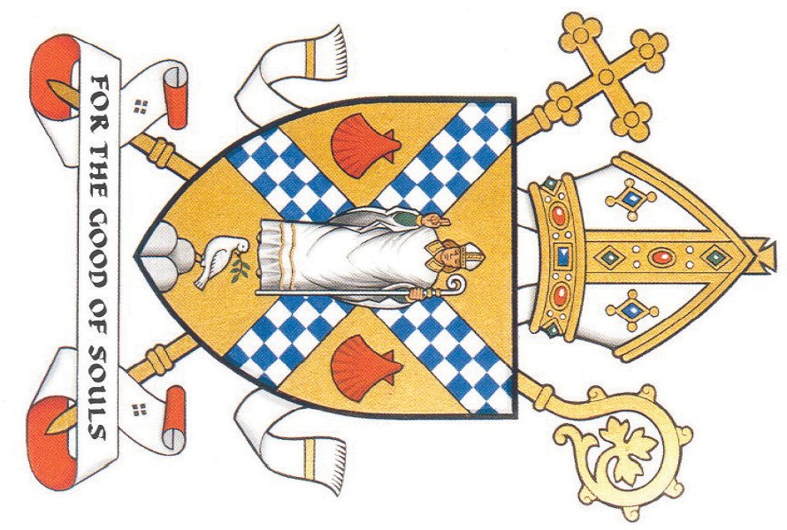

Burns Publications Ltd. 0141 270 9775

